Telling a Story with a Diptych Assignment
Main Entry: dip·tych
Pronunciation: \?dip-(?)tik\
Etymology: Late Latin diptycha, plural, from Greek, from neuter plural of diptychos folded in two, from di- + ptych? fold
Date: 1622
1 : a 2-leaved hinged tablet folding together to protect writing on its waxed surfaces
2 : a picture or series of pictures (as an altarpiece) painted or carved on two hinged tablets
3 : a work made up of two matching parts
Diptychs and triptychs are a brilliant tool for photographic storytelling. They present two or three images which can be from the same session or they can be polar opposites to show opposition or contrasting ideas.
Your assignment is to photograph and present
2 DIFFERENT
photographic Diptych/Triptych stories.
- You can tell any kind of story you want – shoot on the street, photograph an event, set up a little story in your school or home – it’s totally up to you as there are so many possible approaches to take (I’ve included a few ideas below).
- The pair/trio are linked in some way.
  - The link between the two photographs can be:
    - Subject
    - Formal relationships such as light, color, composition
    - Story
    - Theme
    - Binaries such as before/after, easy/hard, sweet/sour, up/down, happy/sad, etc.

- Each Diptych must portray your best photographic skills and be combined using an editing program such as Adobe Photoshop.

- Each Diptych/Triptych MUST include the following details
  - A TITLE for your project
  - Shutter Speed, Aperture Value and ISO for all images
  - Why you chose these photos (use technical and creative aspects of your work) and what story do they tell.

Ensure that BOTH final Diptychs/Triptychs are included in your online portfolio.
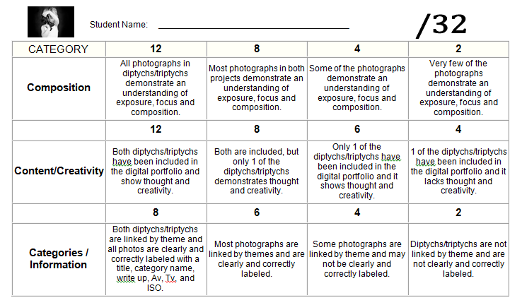

Looking for some Inspiration?
